**Connection to the Largs Urban Area**

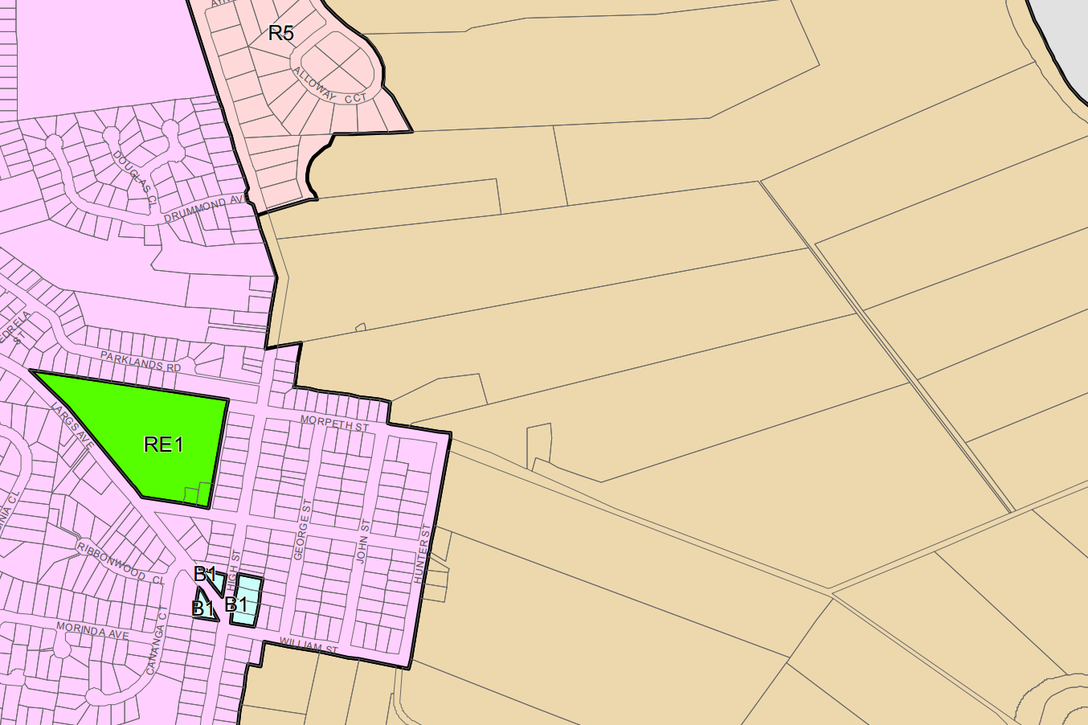

Bus stops at intersection (420m)

-no footpaths

Route to nearest facilities/ services 650m: Bar & Brasserie, Newsagency/ General Store, Hairdresser -no footpaths

**Subject Lot**

Proposed extent of development footprint

68m of site frontage adjoins land zoned for an urban purpose